Tracking Invertebrates
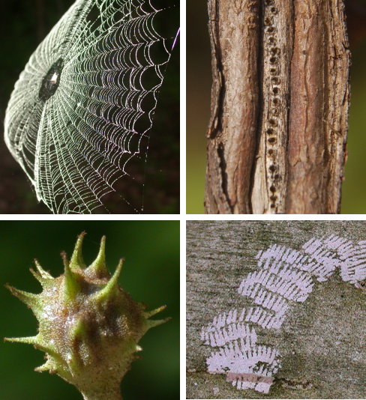
Book Release / Author Talk
Charley Eiseman and Noah Charney will speak about and show images from their new field guide.

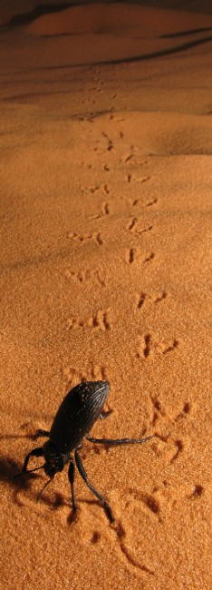

Hitchcock Center for the Environment
Thursday, April 1, 7:30 – 9:00
Registration required: (413) 256-6006

This ground-breaking new reference offers details for identifying beetles, spiders, flies, ants, butterflies, moths, dragonflies, earwigs, mayflies, crickets, grasshoppers, centipedes, millipedes, scorpions, earthworms, slugs, lacewings, wasps, bees, damselflies, alderflies, crabs, and many other invertebrates from the sign they leave behind. It includes almost 1,000 color photos and some 2,000 species in 18 chapters.

Books will be available at $40. For more info, go to:
www.NorthernNaturalists.org

